Power Bi –License Types

Power BI offers several license types to cater to different user needs and organizational requirements. As of my last knowledge update in September 2021, here are the main Power BI license types:

Power BI Free: This is the basic and free version of Power BI. Users can create reports and dashboards but with limited capabilities and sharing options. It's primarily for individual users or small-scale projects.

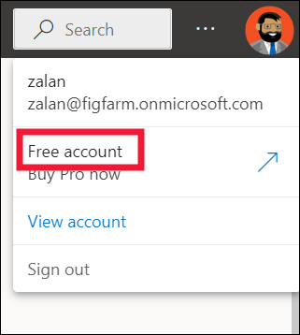

Power BI Pro: Power BI Pro is designed for individual users or small teams. With a Power BI Pro license, users can collaborate and share reports and dashboards within their organization. Users with Pro licenses can publish and consume content created by others in the same organization. This license is priced per user on a monthly or annual basis.

Power BI Premium Per User (PPU): Power BI Premium Per User is a licensing option introduced to provide more advanced capabilities to individual users without the need for a full-scale Power BI Premium subscription. PPU users can access Power BI Premium features, such as paginated reports and AI capabilities, on a per-user basis, rather than a capacity-based license.

Power BI Premium: Power BI Premium is designed for larger organizations or enterprises. It provides dedicated capacity for more consistent performance, supports larger datasets, and offers enhanced security and governance features. With Power BI Premium, users with Free or Pro licenses can access content without needing a Pro license themselves.
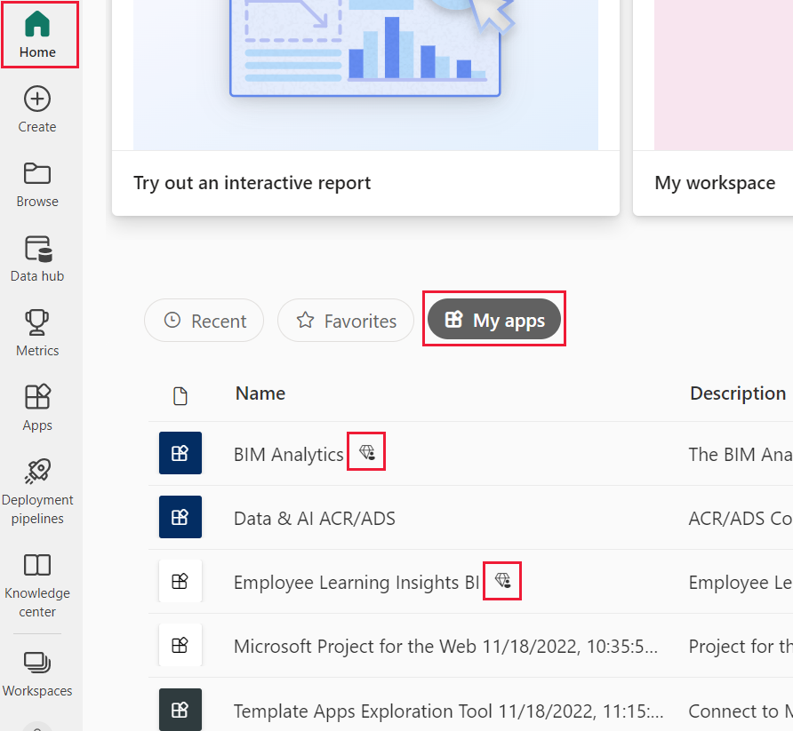

Power BI Embedded: Power BI Embedded is for developers who want to integrate Power BI reports and dashboards into custom applications. It's a capacity-based licensing model where developers pay for the underlying capacity rather than individual user licenses.

Power BI Mobile License: This license is required for users who need access to Power BI content exclusively through the mobile app. It's typically added to a Power BI Pro or Premium Per User subscription.

Power BI Dataflow and Power Automate licensing: These are additional licenses that may be required for specific features, such as Power BI Dataflows for data preparation and transformation, and Power Automate for workflow automation.

Let’s Get Pricing Out of the Way

